Project Report Format

# INTRODUCTION

* 1. Project Overview
  2. Purpose

# LITERATURE SURVEY

* 1. Existing problem
  2. References
  3. Problem Statement Definition

# IDEATION & PROPOSED SOLUTION

* 1. Empathy Map Canvas
  2. Ideation & Brainstorming

# REQUIREMENT ANALYSIS

* 1. Functional requirement
  2. Non-Functional requirements

# PROJECT DESIGN

* 1. Data Flow Diagrams & User Stories
  2. Solution Architecture

# PROJECT PLANNING & SCHEDULING

* 1. Technical Architecture
  2. Sprint Planning & Estimation
  3. Sprint Delivery Schedule

# CODING & SOLUTIONING (Explain the features added in the project along with code)

* 1. Feature 1

# PERFORMANCE TESTING

* 1. Performace Metrics

# RESULTS

* 1. Output Screenshots

# ADVANTAGES & DISADVANTAGES

1. **CONCLUSION**

# FUTURE SCOPE

1. **APPENDIX**

Source Code

GitHub & Project Demo Link

1. **Introduction :**
   1. **Project Overview:**

**Project Name:** Fetal Health Monitoring and Prediction with AI

**Project Objective:** The primary objective of this project is to develop and implement AI-based solutions for monitoring and predicting the health of the fetus during pregnancy. The goal is to enhance the quality of prenatal care, ensure early detection of potential health issues, and improve overall maternal and fetal well-being.

**Key Components and Features:**

**1. Data Collection:** The project starts with the collection of relevant data, including maternal health records, ultrasound images, vital signs, and other medical information. This data forms the basis for AI analysis.

**2. AI Models:** AI models are developed and trained to analyze the collected data. These models can include machine learning algorithms, deep learning networks, and natural language processing techniques. The AI models can provide various functionalities, including:

* **Fetal Monitoring:** Continuous monitoring of fetal heart rate, movement, and other indicators to assess the well-being of the fetus.
* **Predictive Analytic:** Predicting the likelihood of pregnancy complications, such as preterm birth, pre-eclampsia, or gestational diabetes.
* **Anomaly Detection:** Detecting anomalies or deviations from the normal development of the fetus, which can be indicative of potential health issues.
* **Health Recommendations:** Providing healthcare providers with actionable insights and recommendations based on AI analysis.

**3. User Interfaces:** The project may include user-friendly interfaces for healthcare providers and expectant parents. These interfaces can display real-time data, predictions, and recommendations in an easily understandable format.

**4. Integration with Healthcare Systems:** Seamless integration with electronic health records (EHRs) and hospital information systems to ensure that healthcare providers have access to AI-generated insights during prenatal care appointments.

**5. Alerts and Notifications:** The AI system can generate alerts and notifications for healthcare providers in the event of critical health indicators or potential complications, enabling timely intervention.

**Benefits:**

* **Early Detection:** Fetal AI can help in early detection of potential health issues, allowing for timely intervention and better outcomes for both the mother and the fetus.
* **Personalized Care:** AI can provide personalized recommendations and care plans based on the unique characteristics and health history of the pregnant individual.
* **Reduced Healthcare Costs:** By preventing complications and reducing the need for emergency interventions, the project can potentially lower healthcare costs associated with prenatal care.
* **Improved Patient Experience:** Expectant parents can benefit from greater peace of mind, as they are more informed about the health of their unborn child and can actively participate in their care.

**Challenges:**

* **Data Privacy and Security:** Handling sensitive health data requires robust security measures to protect patient privacy.
* **Regulatory Compliance:** Compliance with healthcare regulations, such as HIPAA in the United States, is critical.
* **Interoperability:** Ensuring that the AI system can seamlessly integrate with existing healthcare infrastructure is a technical challenge.
* **Ethical Considerations:** Ethical considerations around consent, transparency, and decision-making should be addressed in the project.
  1. **Purpose :**

The purpose of a fetal AI project is to leverage artificial intelligence and data analytics to enhance the monitoring and prediction of fetal health during pregnancy. By collecting and analyzing a wealth of medical data, including maternal health records and ultrasound images, the project aims to provide early detection of potential health issues, allowing for timely intervention. This technology empowers healthcare providers with AI-generated insights, enabling them to make informed decisions and provide personalized care plans. Expectant parents can benefit from greater peace of mind, as they are more actively involved in monitoring their unborn child's health. Ultimately, the purpose of a fetal AI project is to improve maternal and fetal outcomes, reduce healthcare costs, and revolutionize prenatal care by offering a proactive and data-driven approach to pregnancy management.

1. **Literature Survey:**

**2.1 Existing Problem:**

Existing problems in prenatal care include limited access to continuous fetal health monitoring, potential delays in detecting complications, and the reliance on periodic, often subjective assessments during prenatal visits. These limitations can result in missed opportunities for early intervention in cases of fetal distress or maternal complications. Additionally, the current approach may not fully leverage the vast amount of health data available to inform and personalize prenatal care. The lack of a proactive and data-driven system can lead to sub optimal outcomes for both the mother and the fetus, increased healthcare costs, and a less satisfying prenatal care experience for expectant parents. Addressing these challenges is crucial for improving the quality and effectiveness of prenatal care.

**2.2 References:**

1. Meshaka, Riwa, Trevor Gaunt, and Susan C. Shelmerdine. "Artificial intelligence applied to fetal MRI: A scoping review of current research." The British Journal of Radiology 96.1147 (2023): 20211205.
2. Mennickent, Daniela, et al. "Machine learning applied in maternal and fetal health: a narrative review focused on pregnancy diseases and complications." Frontiers in Endocrinology 14 (2023): 1130139.
3. Das, Sahana, et al. "Fetal Health Classification from Cardiotocograph for Both Stages of Labor—A Soft-Computing-Based Approach." Diagnostics 13.5 (2023): 858.
4. Abiyev, Rahib, et al. "Fetal Health State Detection Using Interval Type-2 Fuzzy Neural Networks." Diagnostics 13.10 (2023): 1690.

**2.3 Problem Statement Definition:**

The current state of prenatal care is plagued by several critical issues, including limited access to continuous fetal health monitoring, potential delays in detecting complications, disparities in healthcare access, and the absence of a standardized, data-driven approach. These challenges collectively contribute to missed opportunities for early intervention in cases of fetal distress or maternal complications, unequal health outcomes among pregnant individuals, and a lack of proactive, personalized care. The burden of monitoring fetal health often falls on expectant parents, leading to anxiety and uncertainty during pregnancy. Additionally, without a consistent and comprehensive system for tracking and analyzing health data, the healthcare industry misses out on valuable insights that could inform more effective prenatal care. Addressing these issues is paramount to improving the quality of prenatal care, ensuring equitable access, and enhancing the overall experience for expectant parents.

1. **Ideation & Proposed Solution:**
   1. **Empathy Map Canvas:**

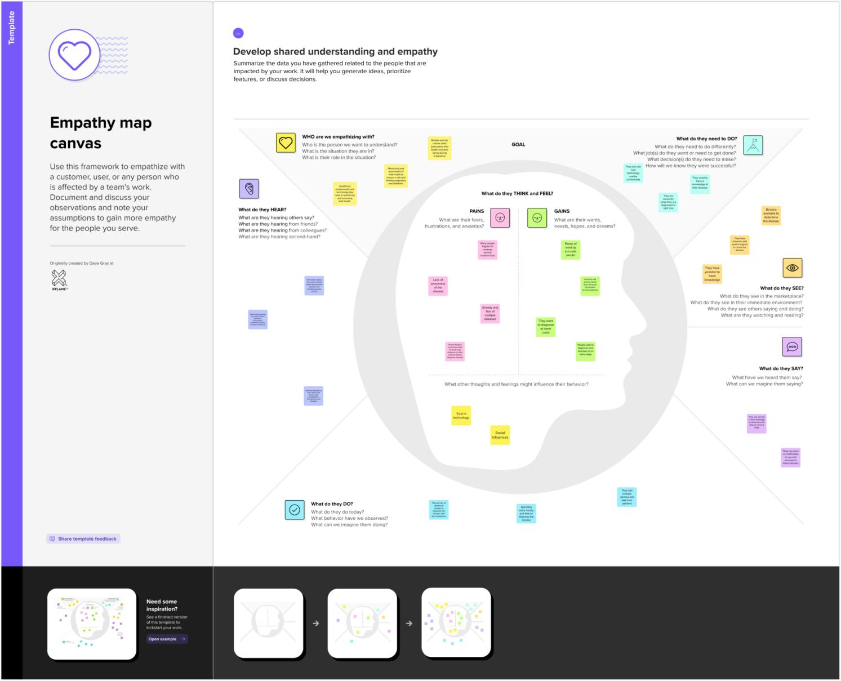

* 1. **Ideation & BrainStorming:**

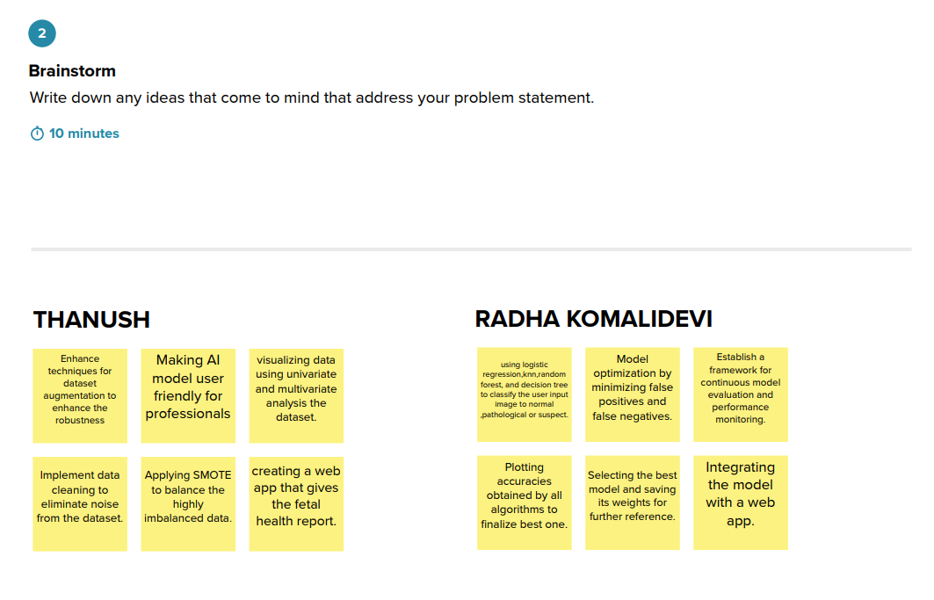

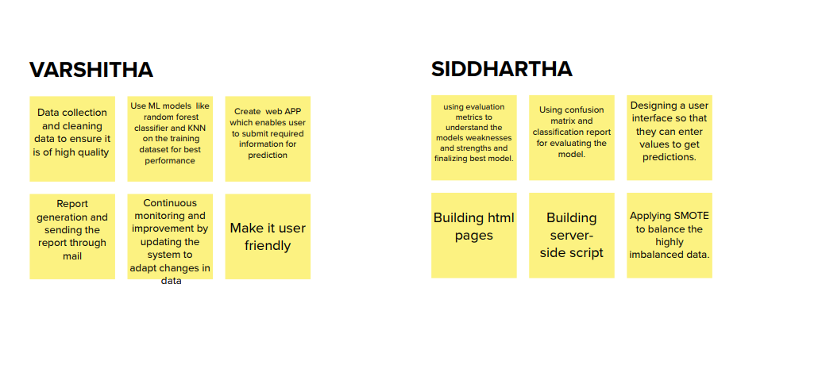

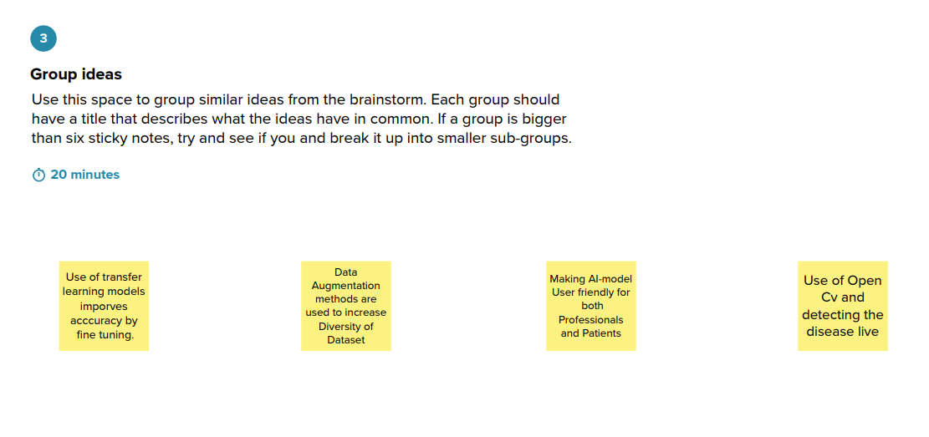

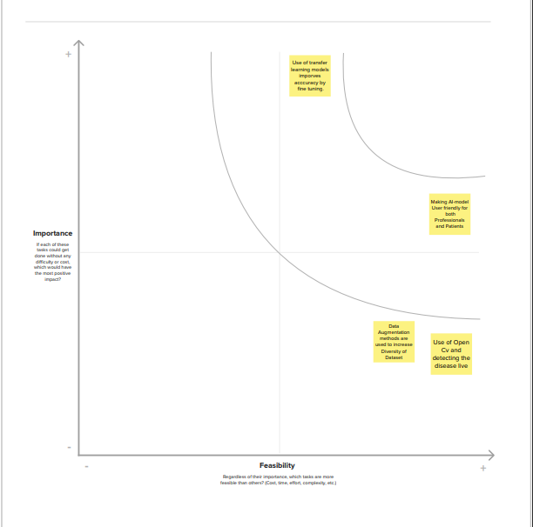

1. **Requirement Analysis:**

**4.1 Functional Requirement:**

The fetal AI system must provide continuous and accurate monitoring of fetal health indicators, including heart rate, movement, and other vital signs. It should be capable of predictive analytics to detect potential complications such as preterm birth, preeclampsia, and gestational diabetes. The system should offer real-time alerts and notifications to healthcare providers in the event of critical health indicators or anomalies, enabling timely intervention. It must integrate seamlessly with electronic health records (EHRs) and hospital information systems for healthcare providers to access AI-generated insights during prenatal care appointments. The AI system should have user-friendly interfaces for healthcare providers and expectant parents to display real-time data, predictions, and recommendations in an easily understandable format. Personalized care recommendations based on unique characteristics and health history should be a fundamental feature, enhancing the quality of prenatal care.

**4.2 Non-Functional Requirement:**

The fetal AI system must prioritize data privacy and security, implementing robust encryption and access control measures to safeguard sensitive healthcare information. It should comply with healthcare regulations such as HIPAA to ensure the ethical handling of patient data. The system's performance should be scalable to accommodate a wide range of healthcare facilities and handle the increasing volume of health data. High availability and reliability are essential, ensuring that the system remains operational 24/7 to provide continuous monitoring and support for expectant parents and healthcare providers. The system should also exhibit responsiveness, with minimal latency in generating alerts and recommendations. It should be user-friendly and designed with a focus on accessibility, catering to diverse user demographics, including healthcare professionals and pregnant individuals with varying levels of technical expertise. Lastly, the AI system must be adaptable to different healthcare settings, allowing for customization and integration with existing infrastructure and technologies.

1. **Project Design:**
   1. **DataFlow Diagrams & User Stories:**

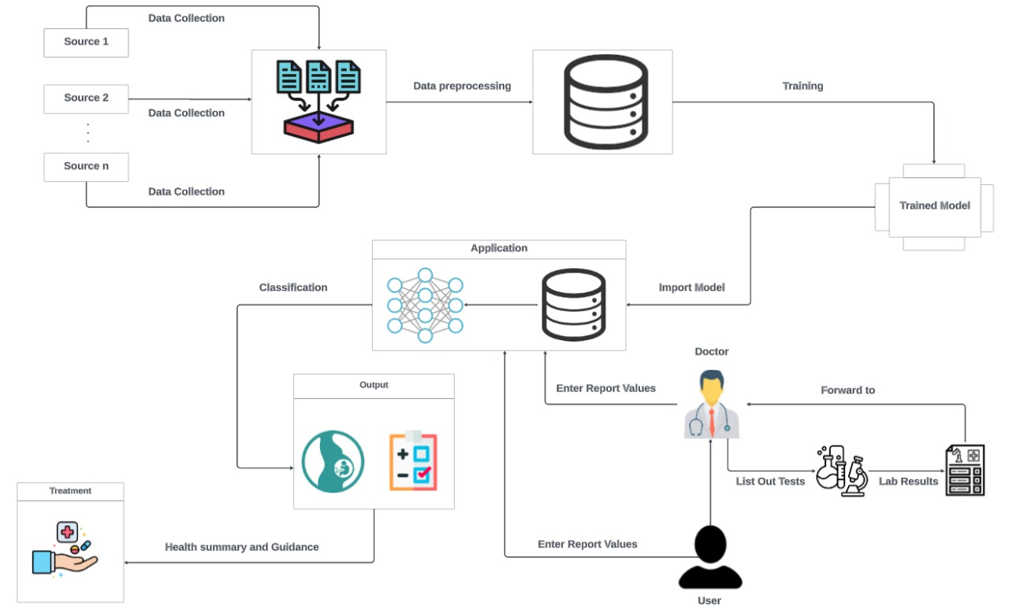

**User Stories:**

|  |  |  |  |  |  |  |
| --- | --- | --- | --- | --- | --- | --- |
| **User Type** | **Functional Requirement (Epic)** | **User Story Number** | **User Story / Task** | **Acceptance criteria** | **Priority** | **Release** |
| Expecting parent | User Registration | USN-1 | I can register for the fetal health prediction application by providing my name, email, and creating a secure password. | I can access my account/dashboard | High | Sprint 1 |
| Government Hospitals and Local Laboratories | User Registration | USN-2 | I can register using my professional credentials and affiliation details to access advanced features for fetal health analysis. | I can access my account | High | Sprint 1 |
| Research  collaborator | User Registration | USN-3 | I can register with my institution's email to contribute ultrasound data for research purposes, after approval from the system administrator. | I can access my account/dashboard | medium | Sprint 2 |
| Carrying woman | User profile | USN-4 | I can complete my profile by adding my partner's information and expected due date to personalize the fetal health predictions. | Create profile | medium | Sprint 2 |
| Healthcare provider | User profile | USN-5 | I can update my profile to include my specialization and certifications for accurate identification within the application. | Create/update profile | medium | Sprint 2 |
| Carrying woman | Fetal health prediction | USN-6 | I can enter test results in the application for fetal health analysis. | I can know health analysis | high | Sprint 1 |
| Healthcare professional | Fetal health prediction | USN-7 | I can input detailed ultrasound measurements and parameters to obtain in-depth fetal health predictions for my patients. | I can gain in-depth vital information | high | Sprint 2 |
| father | Fetal health prediction | USN-8 | I can view the fetal health predictions, including vital statistics and potential risks, in an easy-to-understand format. | I can easily understand the statistics, risks through the format. | Medium | Sprint 1 |
| Healthcare provider | Fetal health prediction | USN-9 | I can receive real-time notifications for high-risk predictions, enabling immediate intervention and consultation with specialists. | I can stay relieved. | High | Sprint 1 |
| parents | health care | USN-10 | I can access educational resources and articles about fetal health and development to stay informed about my baby's progress. | I can take care of my baby much better. | high | Sprint 2 |
| mother | healthcare | USN-11 | I can set up personalized notifications for appointment reminders, fetal development updates, and health tips. | I can take much more care. | High | Sprint 1 |
| Healthcare professional | healthcare | USN-12 | I can download comprehensive health reports in PDF format for my patients, including graphical representations of the fetal health data. | I can keep record of previous test results and compare with current ones for checking improvement. | low | Sprint 3 |
| mother | User support | USN-13 | I can contact customer support via chat or email to seek assistance with uploading ultrasound images, understanding predictions, or any other issues. | I can get guidance to use such a vital app. | high | Sprint 1 |
| Registered user | User support | USN-14 | I can access a frequently asked questions (FAQ) section to find quick solutions to common queries about using the application. | I can know using app much better and get to explore well . | high | Sprint 1 |
| Developer | model deployment & Integration | USN-15 | I can deploy the trained machine learning model as an API or service to enable integration with existing healthcare systems for continuous fetal health monitoring. | we could check the  scalability | medium | Sprint 1 |
| Tester | Testing & quality assurance | USN-16 | I can conduct extensive testing and validation of the machine learning model's predictions and the user interface's functionality to ensure accuracy and reliability. | we could create web application | medium | Sprint 1 |

* 1. **Solution Architecture:**

This system utilizes Convolutional Neural Networks (CNNs) to enhance fetal health monitoring by providing real-time classification. By leveraging the power of CNNs, it improves both the accuracy and efficiency of the monitoring process, ensuring the well-being of the fetus and promoting a more positive pregnancy experience for expectant mothers. Furthermore, the incorporation of a continuous learning loop enables the system to adapt to new data and evolving patterns, maintaining a high classification accuracy over time. In summary, this innovation has the potential to revolutionize fetal health monitoring, making it more reliable and reassuring for mothers during their pregnancy journey.

Our solution leverages Convolutional Neural Networks (CNNs) to address the Fetal Health Monitoring problem effectively.

* Data Gathering
* Data Preprocessing
* Model Building
* Fetal Health Prediction
* Real Time Analysis

**Solution Architecture Diagram**

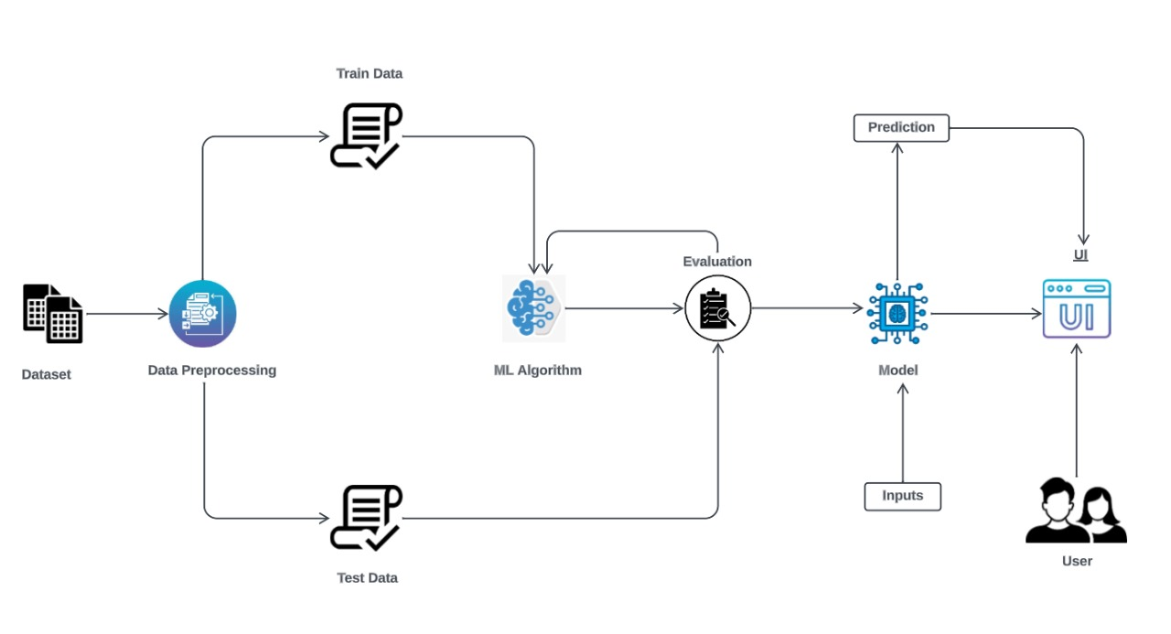

1. **Project Planning & Scheduling** 
   1. **Technical Architecture:**

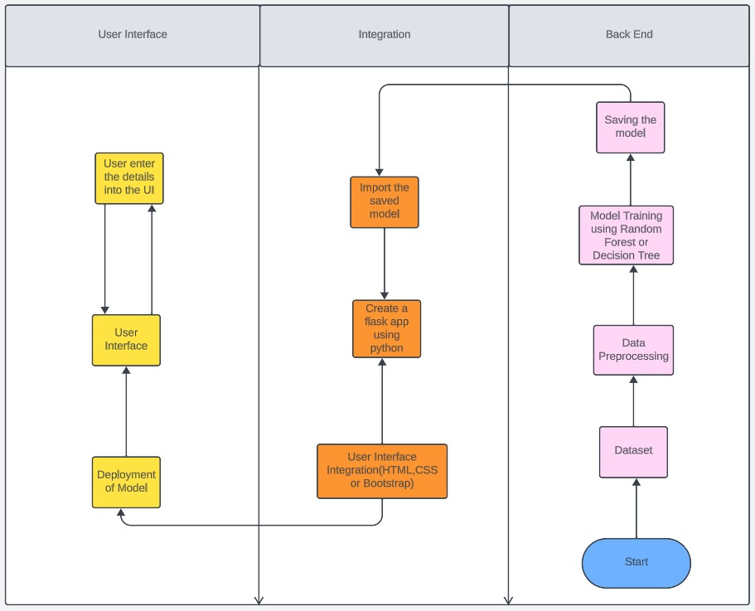

Table-1 : Components & Technologies:

|  |  |  |  |
| --- | --- | --- | --- |
| **S.No** | **Component** | **Description** | **Technology** |
| 1. | Data Collection Sensors | Fetal heart rate sensors, uterine activity sensors | Medical-grade sensors and transducers |
| 2. | Data Processing Module | Data pre-processing, signal processing, feature extraction | Python, MATLAB |
| 3. | Machine Learning Model | Fetal distress prediction model | TensorFlow, scikit-learn |
| 4. | Database | Data Type, Configurations, etc. | Relational or NoSQL database for storing monitoring data |
| 5. | Cloud Integration | Cloud storage for remote access and data backup | Amazon Web Services (AWS), Google Cloud Platform (GCP) |
| 6. | User Interface | Patient and healthcare professional interfaces | Web-based dashboard, mobile application |
| 7. | Alerting System | Real-time alerts for abnormal fetal conditions | Email, SMS, push notifications |
| 8. | Security | Data encryption, user authentication | SSL, OAuth |
| 9. | Reporting | Generation of reports and charts | Aadhar API, etc. |
| 10. | Machine Learning Model | Purpose of Machine Learning  Model | Reporting libraries, data visualization tools |
| 11. | Infrastructure (Server / Cloud) | Application Deployment on Local System / Cloud Local Server Configuration:  Cloud Server Configuration : | Local, Cloud Foundry, Kubernetes, etc. |

Table-2: Application Characteristics:

|  |  |  |  |
| --- | --- | --- | --- |
| **S.No** | **Characteristics** | **Description** | **Technology** |
| 1. | Open-Source Frameworks | List the open-source frameworks used in the application. | Technology stack of the open-source framework, e.g., Django (Python), Angular (JavaScript), Spring Boot (Java), etc. |
| 2. | Security Implementations | List all the security and access controls implemented, including the use of firewalls, encryption techniques, IAM (Identity and Access Management) controls, and adherence to OWASP (Open Web Application Security Project) guidelines. | Technology or cryptographic methods used, e.g., SHA-256 for data hashing, SSL for encryption, Role-Based Access Control (RBAC), and security libraries.. |
| 3. | Scalable Architecture | Justify the scalability of architecture (3 – tier, Micro-services) | Technology stack and architectural patterns that enable scalability, e.g., Docker and Kubernetes for containerization and orchestration in microservices, or load balancers for horizontal scaling in a 3-tier architecture. |
| 4. | Availability | Justify the availability of the application, such as the use of load balancers, distributed server configurations, or other redundancy mechanisms. | load balancers like NGINX or HAProxy, distributed databases like Cassandra or MongoDB, or failover mechanisms. |
| 5. | Performance | Design considerations for the application's performance, including metrics like the number of requests per second, the use of caching mechanisms, and Content Delivery Networks (CDNs). | Redis for caching, CDN services like Cloudflare or Akamai, load testing frameworks like Apache JMeter, or optimization libraries for database queries. |

* 1. **Spirint Planning and Estimation:**

|  |  |  |  |  |  |  |
| --- | --- | --- | --- | --- | --- | --- |
| **Sprint** | **Functional**  **Requirement (Epic)** | **User Story**  **Number** | **User Story / Task** | **Story**  **Points** | **Priority** | **Team**  **Members** |
| Sprint-1 | Project Setup & Infrastructure | USN-1 | Set up the development environment with the required tools and frameworks to start the Fetal Health Monitoring Project. | 1 | High | Varshitha |
| Sprint-1 | development environment | USN-2 | Collect a diverse dataset of fetal health records and associated maternal health data for training the deep learning model. | 2 | High | Radha |
| Sprint-2 | Data collection | USN-3 | Preprocess the collected dataset by handling missing values, normalizing features, and ensuring data quality before splitting it into training and validation sets. | 2 | High | Siddartha |
| Sprint-2 | data preprocessing | USN-4 | Explore various deep learning algorithms (e.g., CNNs) and models suitable for predicting fetal health based on the preprocessed dataset. | 3 | High | Thanush |
| Sprint-3 | model development | USN-5 | Train the selected deep learning model using the preprocessed dataset and monitor its performance on the validation set. | 4 | High | Siddartha |
| Sprint-3 | Training | USN-6 | Implement anomaly detection techniques to identify potential risks or abnormalities in fetal health monitoring data. | 6 | medium | Varshitha |
| Sprint-4 | model deployment & Integration | USN-7 | Deploy the trained machine learning model as an API or service to enable integration with existing healthcare systems for continuous fetal health monitoring. | 1 | medium | Radha |
| Sprint-5 | Testing & quality  assurance | USN-8 | Conduct extensive testing and validation of the machine learning model's predictions and the user interface's functionality to ensure accuracy and reliability. | 1 | medium | Thanush |

* 1. **Sprint Delivery Schedule:**

|  |  |  |  |  |  |  |
| --- | --- | --- | --- | --- | --- | --- |
| **Sprint** | **Total Story Points** | **Duration** | **Sprint Start Date** | **Sprint End Date (Planned)** | **Story Points Completed (as on**  **Planned End Date)** | **Sprint Release Date (Actual)** |
| Sprint-1 | 3 | 3 Days | 1 Nov 2023 | 3 Nov 2023 | 20 | 3 Nov 2023 |
| Sprint-2 | 5 | 5 Days | 4 Nov 2023 | 8 Nov 2023 |  |  |
| Sprint-3 | 10 | 7 Days | 9 Nov 2023 | 15 Nov 2023 |  |  |
| Sprint-4 | 1 | 7 Days | 16 Nov 2023 | 19 Nov 2023 |  |  |
| Sprint-5 | 1 | 3 Days | 19 Nov 2023 | 21 Nov 2023 |  |  |

**Velocity:**

Imagine we have a 25-days sprint duration, and the velocity of the team is 20 (points per sprint). Let’s calculate the team’s average velocity (AV) per iteration unit (story points per day)

# AV= 25/20 = 1.25

**Burndown Chart:**

A burndown chart is a graphical representation of work left to do versus time. It is often used in agile [software development](https://www.visual-paradigm.com/scrum/what-is-agile-software-development/) methodologies such as [Scrum](https://www.visual-paradigm.com/scrum/scrum-in-3-minutes/). However, burn down charts can be applied to any project containing measurable progress over time.

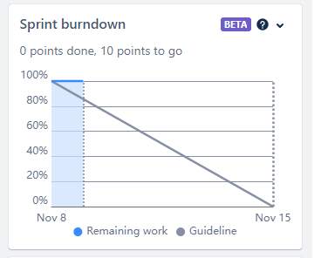

**Board section:**

We have completed sprint 1 and 2. So we can see the remaining tasks on board.

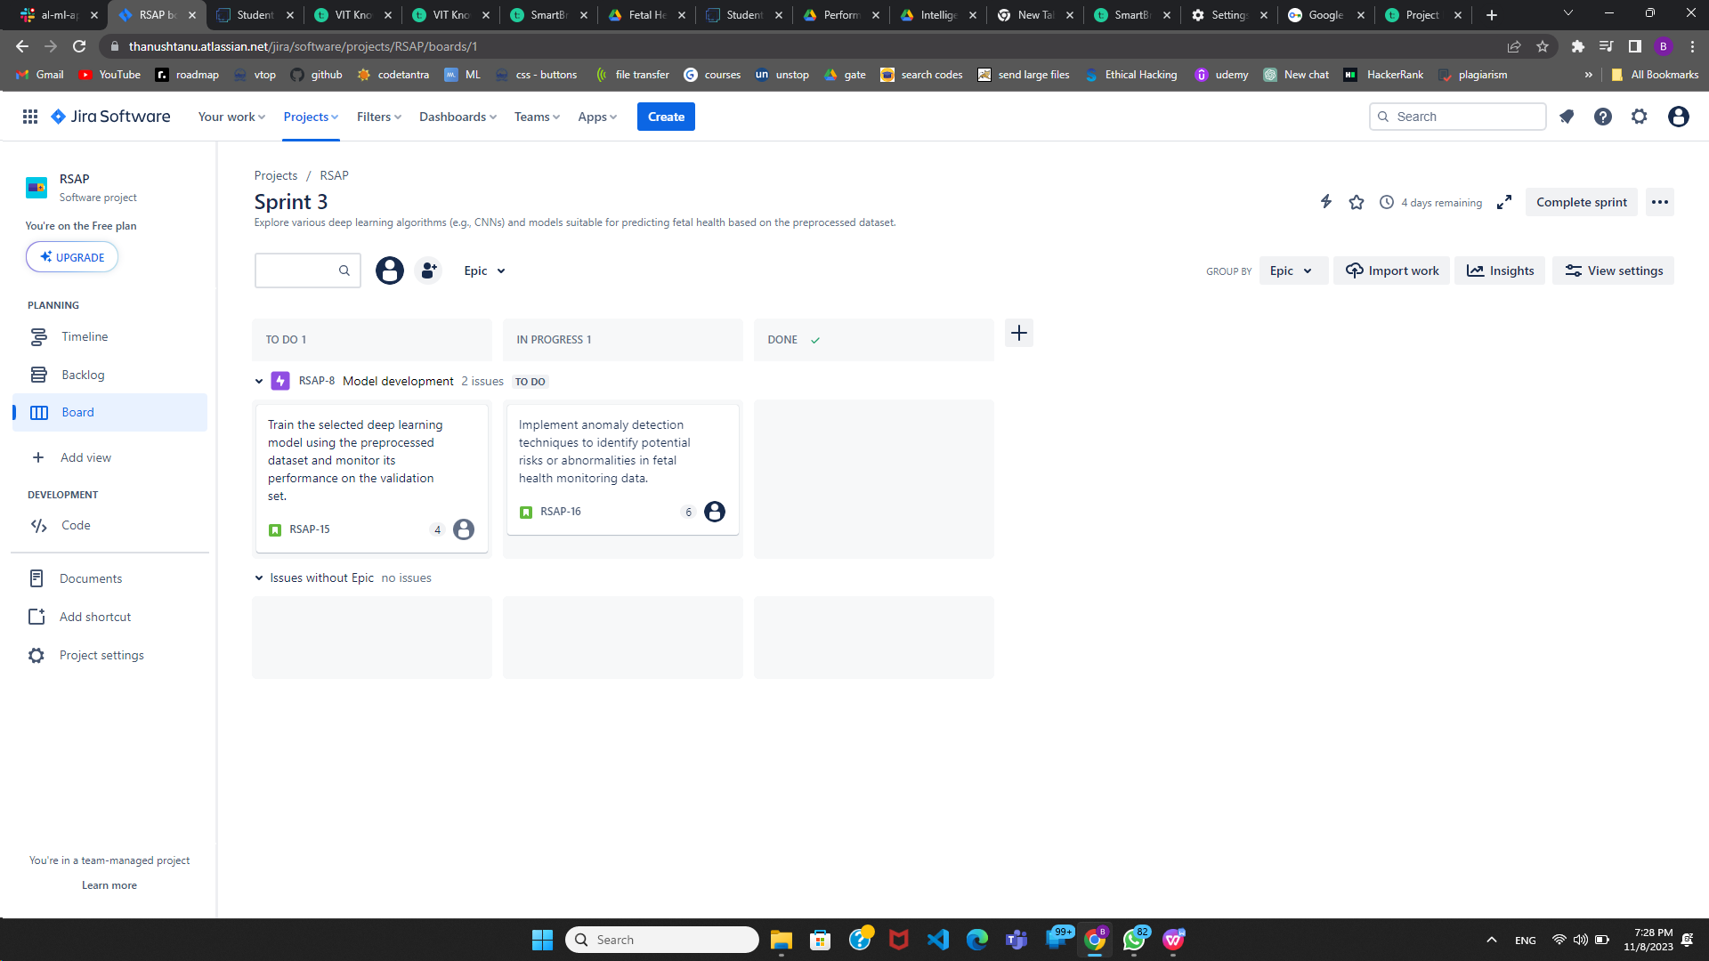

**Backlog section:**

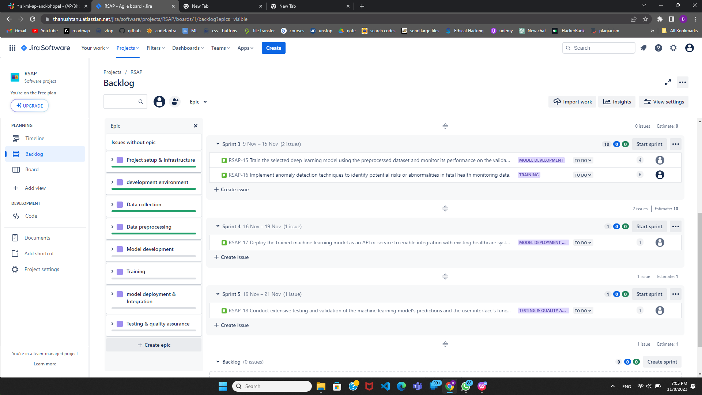

**Timeline:**

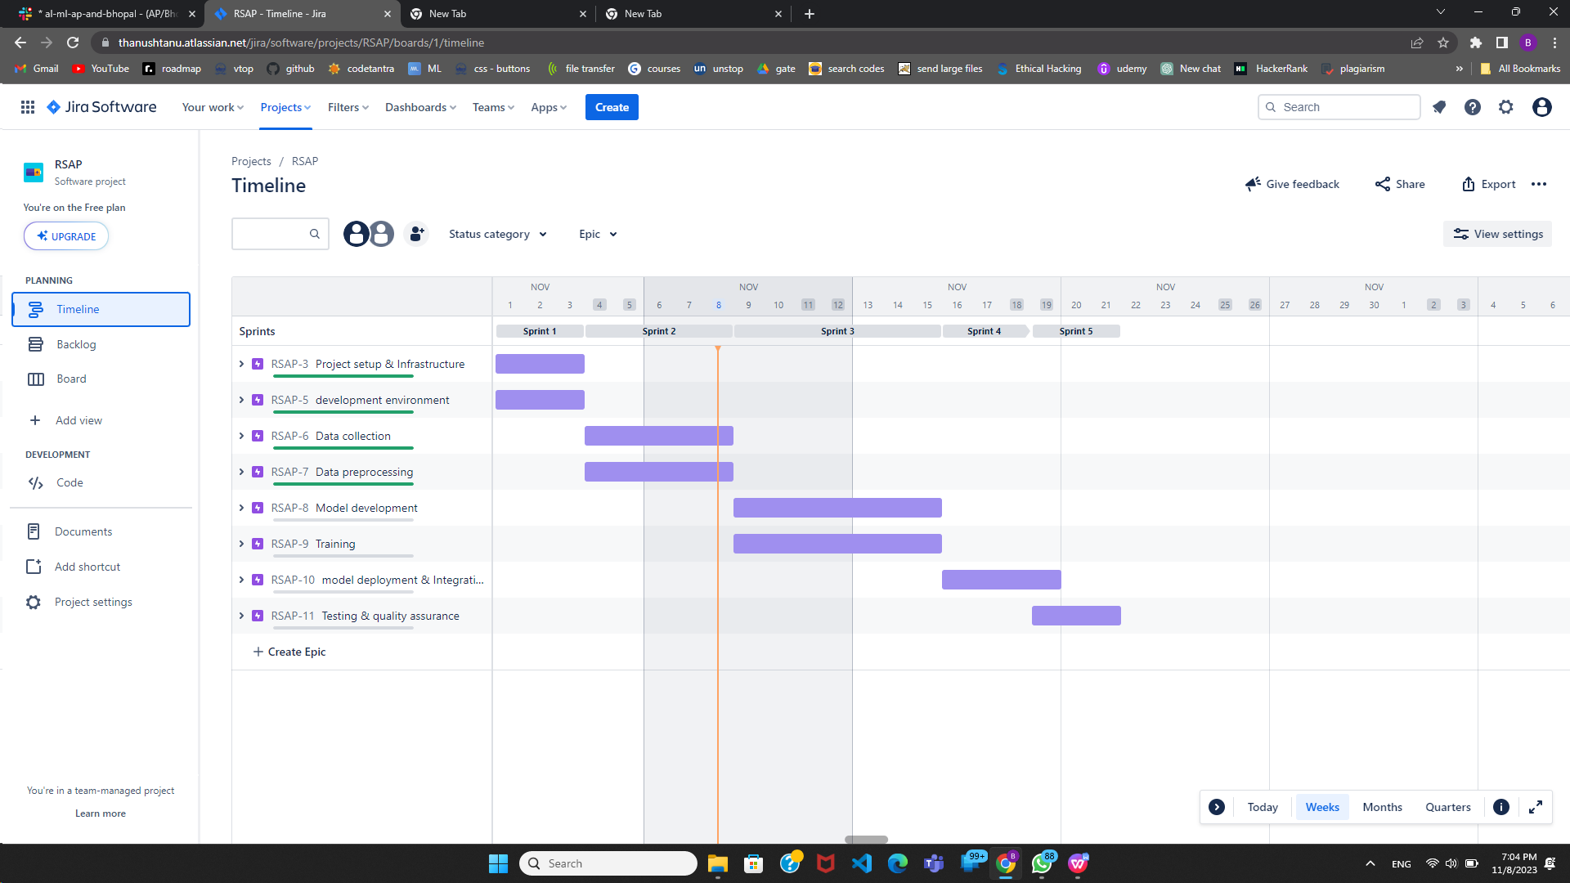

1. **CODING & SOLUTIONING**

**7.1 Feature Selection**

In our data analysis process, we conducted a thorough examination of the dataset to identify the key features that significantly influence the prediction of fetal health. We employed correlation analysis to measure the relationships between different variables and their impact on the outcome. Through this analysis, we identified a subset of features that exhibited strong correlations with fetal health, while other variables showed relatively weaker associations. After careful consideration and prioritization, we made the strategic decision to focus on the top 8 features that had the highest correlation with fetal health, as these are likely to play a pivotal role in enhancing the accuracy and reliability of our health predictions for fetuses. By narrowing down our focus to these high-priority features, we aim to improve the effectiveness of our predictive models and contribute to better outcomes in fetal health assessment and care. This streamlined approach not only simplifies the analysis but also ensures that our resources and efforts are dedicated to the most influential factors, ultimately leading to more accurate and valuable predictions for fetal health.

**Given Values:**

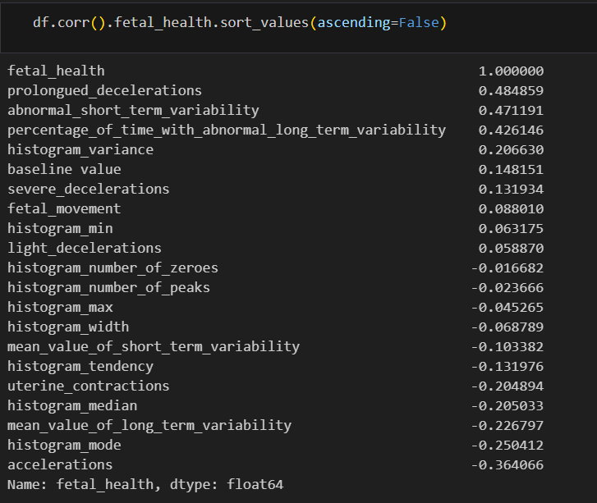

**Selected Values:**

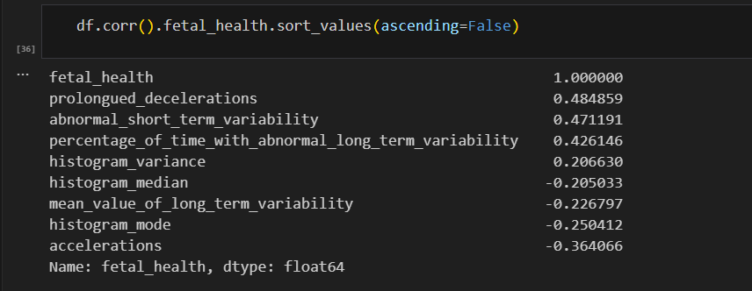

1. **Performance Testing** 
   1. **Performance Metrics**

|  |  |  |  |
| --- | --- | --- | --- |
| **S.No.** | **Parameter** | **Values** | **Screenshot** |
| 1. | Model Summary | **-** |  |
| 2. | Accuracy | Training Accuracy - 0.99712  Validation Accuracy - 0.91849 |  |

**Confusion Matrix:**

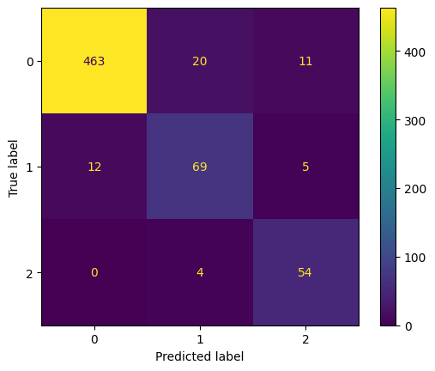

**Classification Report:**

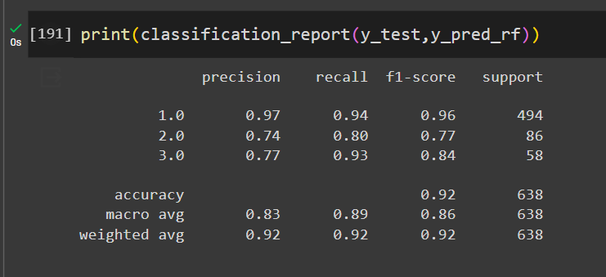

1. **Results**
   1. **Output Screenshots**

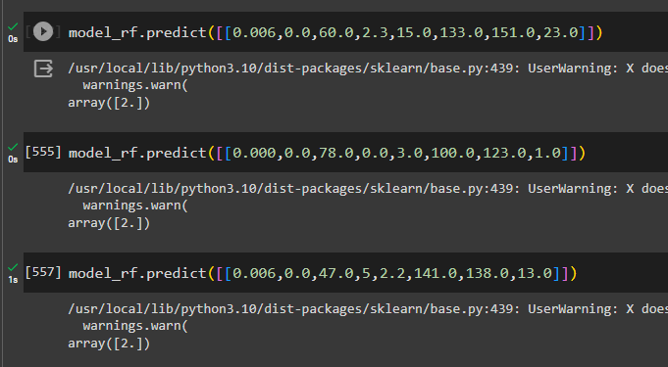

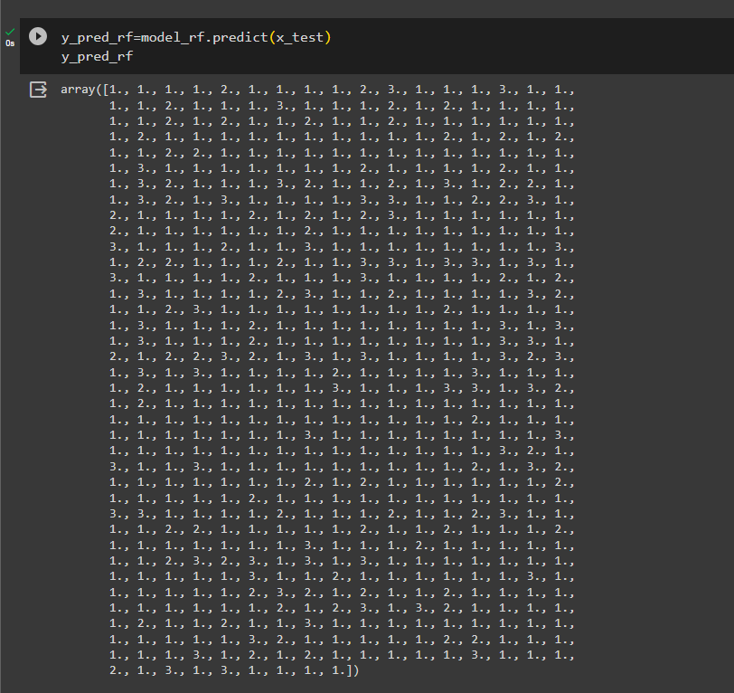

1. **Advantages and Disadvantages** 
   1. **Advantages:**

Implementing a fetal AI system in prenatal care offers a multitude of benefits. Firstly, it enables early detection of potential health issues in both the mother and the fetus, allowing for timely intervention and improved health outcomes. This proactive approach reduces the risks associated with pregnancy complications and lowers healthcare costs by minimizing the need for emergency interventions. Furthermore, the system provides personalized and data-driven recommendations, enhancing the quality of care for expectant parents and increasing their peace of mind. It empowers healthcare providers with AI-generated insights, enabling more informed decision-making and more efficient patient management. Additionally, the technology bridges healthcare access disparities, ensuring that a broader demographic of pregnant individuals can receive equitable, high-quality prenatal care. Overall, a fetal AI system has the potential to revolutionize prenatal care by offering a comprehensive and proactive approach to monitoring and enhancing the health and well-being of both the mother and the fetus.

* 1. **Disadvantages**

While the implementation of a fetal AI system in prenatal care offers significant advantages, it also comes with certain disadvantages and challenges. One notable concern is the potential for data privacy and security breaches, given the sensitive nature of healthcare information. Ensuring robust security measures and compliance with regulations is crucial but can be complex and costly. Additionally, the technology may not be equally accessible to all pregnant individuals, potentially exacerbating healthcare disparities, as it could be cost-prohibitive or require high-tech infrastructure not available in all healthcare settings. The system's reliance on AI may also lead to over-reliance on technology, potentially reducing the human touch and personal connection between healthcare providers and expectant parents. Ethical considerations regarding consent, transparency, and decision-making in AI-generated healthcare recommendations should also be carefully addressed. Finally, there is a risk that the AI system could generate false positives or negatives, leading to unnecessary interventions or missed complications. These challenges underline the need for a balanced approach that leverages the benefits of fetal AI while addressing its potential drawbacks.

1. **Conclusion**

In conclusion, the integration of fetal AI technology into prenatal care holds the promise of significantly improving the quality and effectiveness of healthcare for expectant parents and their unborn children. The advantages, such as early detection of complications, personalized care, and reduced healthcare costs, are substantial and can lead to better maternal and fetal outcomes. However, it is essential to navigate the associated disadvantages and challenges, including data privacy concerns, accessibility issues, and ethical considerations. A well-balanced approach that prioritizes security, equity, and ethical guidelines is crucial to harness the full potential of fetal AI technology. With the right safeguards and thoughtful implementation, fetal AI can revolutionize prenatal care, enhancing the overall pregnancy experience and contributing to healthier outcomes for both mothers and their babies.

1. **Future Scope**

The future scope of fetal AI in prenatal care is highly promising, with numerous possibilities for advancement. As technology continues to evolve, we can anticipate even more accurate and sophisticated AI models that can provide earlier and more precise detection of fetal health issues. The integration of wearable devices and telehealth solutions can enhance accessibility and monitoring capabilities, allowing for remote, real-time monitoring and support for expectant parents. Additionally, the use of AI in prenatal care can extend beyond the detection of health issues to proactive health management, such as personalized dietary and lifestyle recommendations tailored to the individual needs of pregnant individuals. Collaborations between AI developers, healthcare professionals, and regulatory bodies will play a crucial role in shaping the future of fetal AI, ensuring its ethical and secure deployment. Ultimately, fetal AI has the potential to continue transforming prenatal care, making it more preventive, data-driven, and patient-centric, offering a brighter and healthier future for mothers and their children.

1. **Appendix**
   1. **Source Code : https://github.com/smartinternz02/SI-GuidedProject-609961-1698211801**
   2. **Github : https://github.com/smartinternz02/SI-GuidedProject-609961-1698211801**
   3. **Demo Video: https://drive.google.com/file/d/1DY128U4SfRyJ997oZ_IgyLAyDtbR4lRe/view?usp=sharing**